Distributed Content Discovery & Inspection Utility
(DCDIU)

Design Documents - Version 0.0

Document Control:

Project Revision History
Date | Version | Author | Brief Description of Changes |  |  |  | Approver Signature
10-02-2026 | Version 1.0 | SAGNIK DEY  TILAK KUMAR  MERSHIKAJAYABAL  RAKSHANA BABU | Initial implementation of core system structure with basic class separation and client-server communication setup.
11-02-2026 | Version 2.0 | SAGNIK DEY  TILAK KUMAR  MERSHIKAJAYABAL  RAKSHANA BABU | Enhanced system with user authentication mechanisms, improved process signaling, and better client session management.
12-02-2026 | Version 3.0 | SAGNIK DEY  TILAK KUMAR  MERSHIKAJAYABAL  RAKSHANA BABU | Implemented timestamp-based logging and comprehensive error handling features.

Team Members

56124 | SAGNIK DEY
56145 | TILAK KUMAR S
58644 | MERSHIKA JAYABAL
56141 | RAKSHANA BABU S

Table of Contents

1) High-Level Design
- Introduction | 5
1.1 Purpose | 5
1.2 Scope | 5
1.3 Definitions | 5
1.4 Overview | 5
2.General Description | 6
2.1 Product Perspective | 6
2.2 Tools used | 6
2.3 General Constraints | 6
2.4 Assumptions | 6
2.5 Special Design aspects | 6
3.Design Details | 6
3.1 Main Design Features | 6
3.2 Application Architecture | 7
3.3 Data Flow Diagram | 8
3.4 Files | 11
3.5 User Interface | 11
3.6 Error Handling | 11
3.7 Help | 11
3.8 Performance | 11
3.9 Security | 11
3.10 Reliability | 11
3.11 Maintainability | 12
3.12 Portability | 13
3.13 Reusability | 13
3.14 Application compatibility | 13
3.15 Resource utilization | 13
3.16 Major Classes | 13
2) Low-Level Design | 14
4. Introduction | 14
4.1 Purpose | 14
4.2 Document Conventions | 14
4.3 Intended Audience and Reading Suggestion | 14
4.4 References | 14
5. Detailed System Design | 14
5.1 Design Description | 15
5.2 Class Diagram | 15
5.3 SEQUENCE Diagram | 15
5.4 USE CASE DIAGRAM | 15
5.5 Design and Implementation constraints | 16
5.6 User Interface | 17
5.7 Security | 18

High Level Design

1. INTRODUCTION
1.1 Purpose

The purpose of this High-Level Design (HLD) document is to provide the necessary design details of the Distributed Content Discovery & Inspection Utility (DCDIU) so that the system can be implemented efficiently.
This document helps in identifying design inconsistencies prior to coding and serves as a reference for understanding high-level module interactions.

  - Scope

This document provides a comprehensive high-level design overview of DCDIU.
It highlights the overall workflow and use cases involved in directory traversal, content discovery, and file inspection, and serves as an input to the Low-Level Design (LLD) document.

  - Definitions

    - DCDIU
Distributed Content Discovery & Inspection Utility (DCDIU) is a POSIX-compliant command-line utility designed to traverse directories, discover file contents based on patterns, and inspect file data.

    - User
A system administrator or user who interacts with DCDIU via a command-line interface.

1.3.3 POSIX File System
A standard-compliant file system that supports POSIX APIs for file and directory operations.

  - Overview

This HLD document is organized as follows:
- Section 1: Introduction – purpose, scope, definitions
- Section 2: General Description – constraints, tools, assumptions
- Section 3: Design Details – architecture, diagrams, interfaces

2. GENERAL DESCRIPTION

2.1 Product Perspective

DCDIU is a standalone command-line utility developed using C++ and POSIX APIs.
The system is designed to help users audit and inspect file contents efficiently across local or distributed file systems.
The system architecture is modular and layered, enabling scalability and maintainability.

2.2 Tools Used

- Linux / POSIX File System
- C++ Programming Language
- GNU Compiler (g++)

2.3 General Constraints

- The application must be CLI-based
- Only POSIX-compliant APIs must be used
- The system must operate in read-only mode

2.4 Assumptions

The assumptions relevant to the system are:
- User has required read permissions
- Target file system is accessible
- Linux terminal environment is available

2.5 Special Design Aspects

The system design is modular, allowing:
- Independent module testing
- Easy addition of new content filters
- Scalability for distributed extensions

3. DESIGN DETAILS

3.1 Main Design Features
The main design features include:
- Modular architecture
- Command-line user interface
- Directory traversal and content scanning
- Logging and exception handling
The design is illustrated using Use Case Diagrams, Data Flow Diagrams, and UML diagrams.

3.2 Application Architecture

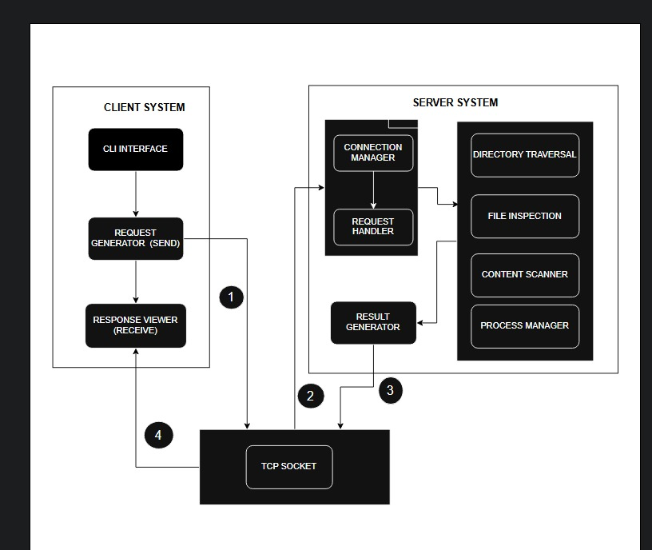

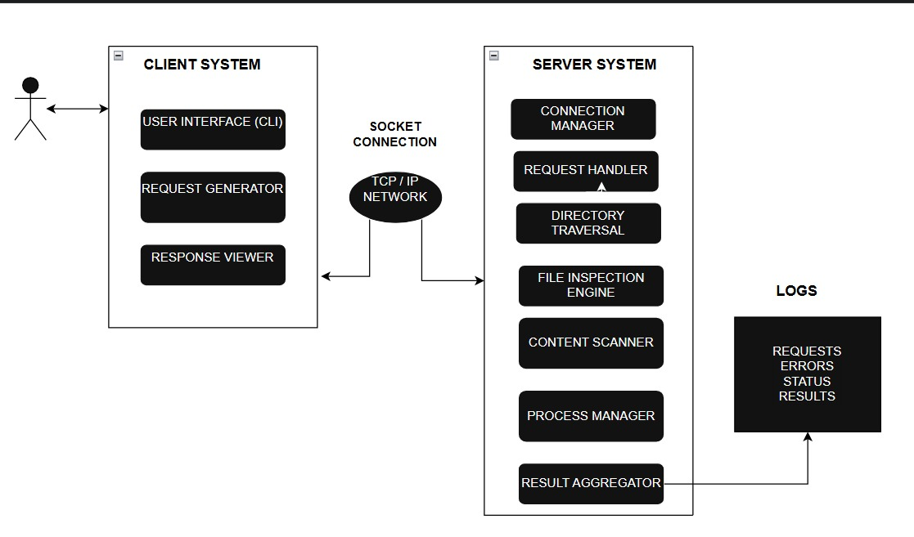
3.2 .1 System Architecture

3.2.2 System Interfaces

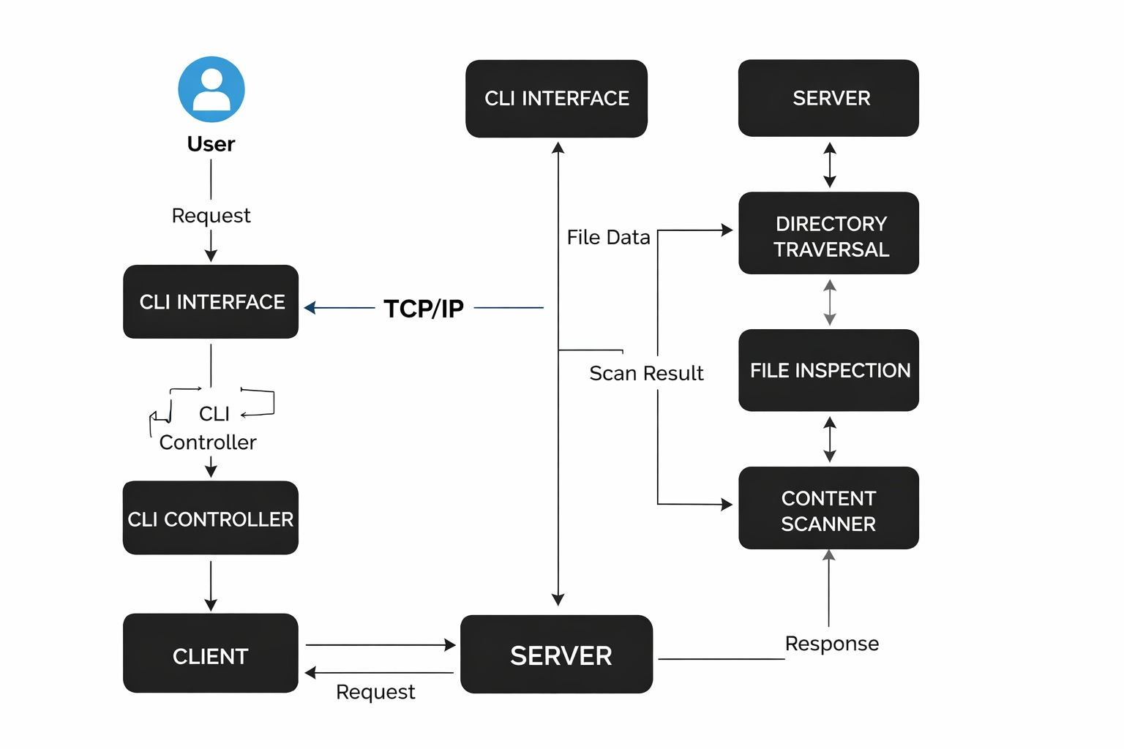

3.4 Data Flow Diagram

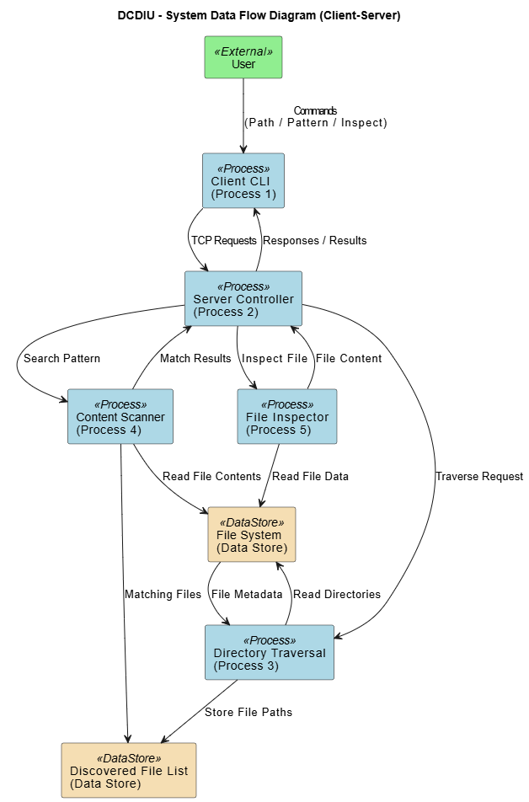

3.5 Files

DCDIU reads files from the local or distributed file system.
The system does not modify, delete, or rename files.

3.6 User Interface

- Desktop or a Linux machine with internet connection.
- Command Line Interface (CLI).

3.7 Error Handling

Error handling is centralized using an ExceptionHandler module.
Handled errors include:
- File not found
- Permission denied
- Invalid input
- Read failures

3.8 Help

Help is provided through:
- Documentation
- CLI prompts
- Usage instructions

3.9 Performance

The system provides efficient traversal and scanning with acceptable response time for large directory structures.
3.10 Security

- Read-only file access
- No file modification
- Permission-based access control enforced by OS

3.11 Reliability

DCDIU ensures stable execution and graceful handling of runtime errors.
Unexpected failures are logged appropriately.

3.12 Maintainability

The modular design ensures:
- Easy debugging
- Easy enhancements
- Minimal maintenance

3.13 Portability

The system is portable across all POSIX-compliant operating systems.
3.14 Reusability

Minimal CPU and memory usage.
No persistent background processes.

3.15 Application compatibility

DCDIU is compatible with standard Linux file systems and POSIX environments.

3.16 Resource utilization: NA

3.17 Major Classes and characteristics

Major classes include:
- CLIController
- DirectoryTraverser
- ContentScanner
- FileInspector
- Logger
- ExceptionHandler

Low Level Design Document

4. Introduction

1. Introduction

The aim of this document is to gather, analyze, and provide an in-depth insight into the complete Distributed Content Discovery & Inspection Utility (DCDIU) by defining the problem statement and solution approach in detail.
The intended audience includes all stakeholders involved in the development and evaluation of the system. These include system administrators, developers, testers, project managers, and evaluators.
This document provides the detailed low-level design of DCDIU, explaining internal module behavior, process flow, data handling, and system interactions at a granular level.

Purpose

The purpose of the Low-Level Design (LLD) document is to describe the internal working and implementation-level design of the Distributed Content Discovery & Inspection Utility.
● DCDIU is a command-line based utility designed to traverse directories, discover file contents based on patterns, and inspect file data.
● The system is implemented using C++ language and makes use of POSIX-compliant system calls.
● DCDIU supports recursive directory traversal, deep content scanning, and file inspection.
● The utility does not modify any files and operates strictly in read-only mode.
● The system is designed to run on POSIX-compliant operating systems such as Linux and UNIX.

4.2 Document Conventions

The document uses the “Times New Roman” font with bold formatting for headings.
- Main heading size: 18 pt
- Sub-heading size: 14 pt
- Sub-heading under sub-heading: 12 pt
- Body text size: 14 pt
All spacing follows the default formatting standards of MS Word.

4.3 Intended Audience and Reading Suggestions

This project is a prototype utility intended for system administrators and developers who need to inspect and audit file contents efficiently.

This document is intended to be read by:

Developers

Testers

Project Managers

Customers / Evaluators

Since this is a technical document, readers are expected to have basic knowledge of:

Linux operating systems

Command Line Interface (CLI)

File systems

C++ programming

4.4 References

The references are

https://www.geeksforgeeks.org/c/c-program-list-files-sub-directories-directory/

https://www.gnu.org/software/libc/manual/html_node/Directory-Interfaces.html

Detailed System Design

The detailed system design of DCDIU is described in this section.
The design focuses on modularity, maintainability, and reliability, and explains how each component works internally.

Design Descriptions

The main design features of DCDIU include four major parts:
- System Architecture
- User Interface Design
- File and Data Handling
- Process Flow and Automation
To make the design easier to understand, the system behavior is illustrated using Use Case Diagrams, Class Diagrams, and Data Flow Diagrams.

Class Diagram

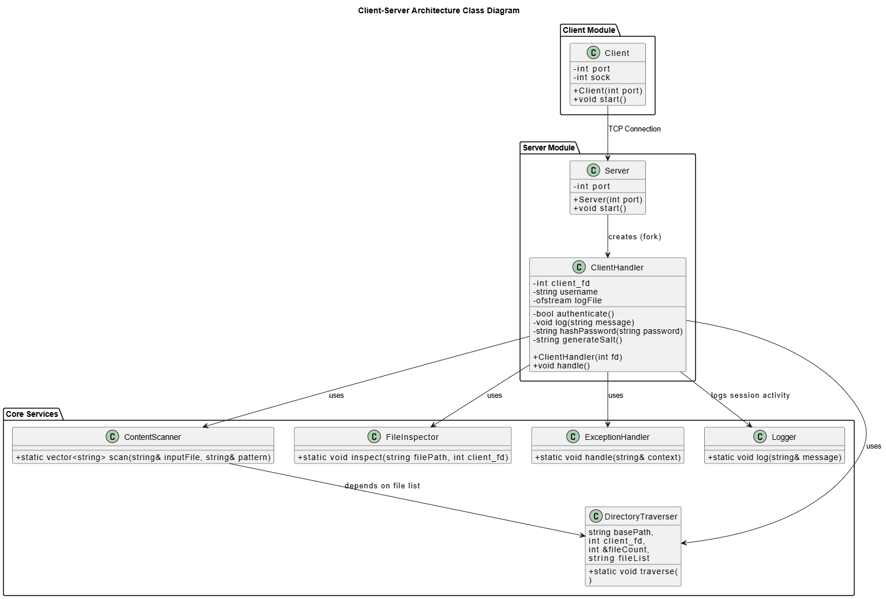
5.3 Sequence Diagram
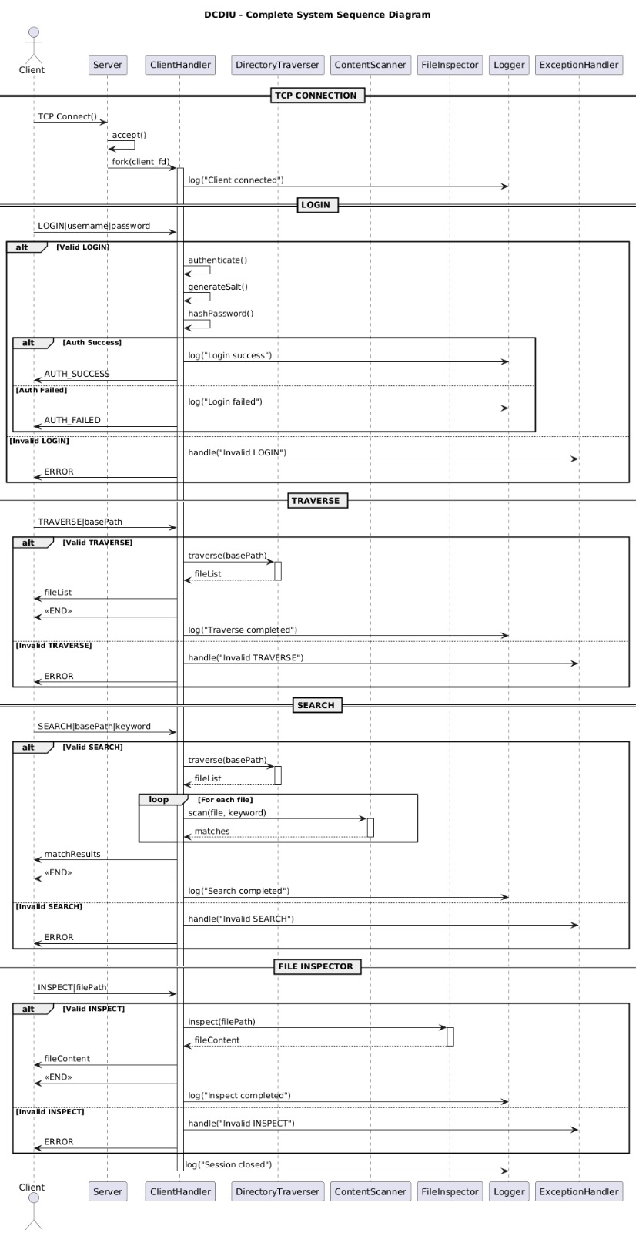

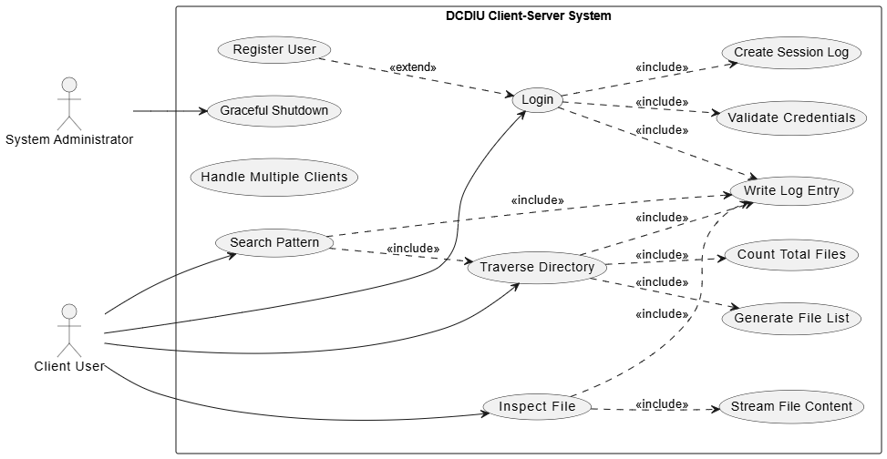
5.4 Use Case Diagram

5.5 Design and Implementation Constraints

The following constraints apply to the system:
- The system is implemented using C++ language
- Only POSIX-compliant APIs are used
- The system operates in read-only mode
- No graphical user interface is provided.

5.6 User Interface

The user interface of DCDIU consists of:
- Desktop or Linux machine with terminal access
- Command Line Interface (CLI)
All interactions are performed using text-based commands and menus.

- Security

DCDIU does not include authentication or authorization mechanisms.
Security is enforced through operating system-level file permissions.
The utility:
- Does not modify files
- Respects read permissions
- Prevents unauthorized access through OS controls
This design ensures that the system does not compromise the security of the host file system.

